

# Perth Modern School

### Semester Two Examination, 2019

### Question/Answer booklet

# 12 METHODS

**UNITs 3 & 4**

## Section One:

## Calculator-free

Your Name

Your Teacher’s Name

## Time allowed for this section

Reading time before commencing work: five minutes

Working time: fifty minutes

## Materials required/recommended for this section

***To be provided by the supervisor***

This Question/Answer booklet

Formula sheet

***To be provided by the candidate***

Standard items: pens (blue/black preferred), pencils (including coloured), sharpener, correction fluid/tape, eraser, ruler, highlighters

Special items: nil

## Important note to candidates

No other items may be taken into the examination room. It is **your** responsibility to ensure that you do not have any unauthorised material. If you have any unauthorised material with you, hand it to the supervisor **before** reading any further.

|  |  |  |  |  |  |
| --- | --- | --- | --- | --- | --- |
| Question | Mark | Max | Question | Mark | Max |
| 1 |  | 6 | 5 |  | 9 |
| 2 |  | 5 | 6 |  | 7 |
| 3 |  | 6 | 7 |  | 7 |
| 4 |  | 10 |  |  |  |

## Structure of this paper

|  |  |  |  |  |  |
| --- | --- | --- | --- | --- | --- |
| Section | Number of questions available | Number of questions to be answered | Working  time (minutes) | Marks available | Percentage of exam |
| Section One:  Calculator-free | 7 | 7 | 50 | 50 | 35 |
| Section Two:  Calculator-assumed | 14 | 14 | 100 | 105 | 65 |
|  | | | **Total** | 155 | 100 |

## Instructions to candidates

1. The rules for the conduct of examinations are detailed in the school handbook. Sitting this examination implies that you agree to abide by these rules.
2. Write your answers in this Question/Answer Booklet.
3. You must be careful to confine your response to the specific question asked and to follow any instructions that are specified to a particular question.
4. Spare pages are included at the end of this booklet. They can be used for planning your responses and/or as additional space if required to continue an answer.

* Planning: If you use the spare pages for planning, indicate this clearly at the top of the page.
* Continuing an answer: If you need to use the space to continue an answer, indicate in the original answer space where the answer is continued, i.e. give the page number. Fill in the number of the question that you are continuing to answer at the top of the page.

1. **Show all your working clearly**. Your working should be in sufficient detail to allow your answers to be checked readily and for marks to be awarded for reasoning. Incorrect answers given without supporting reasoning cannot be allocated any marks. For any question or part question worth more than two marks, valid working or justification is required to receive full marks. If you repeat any question, ensure that you cancel the answer you do not wish to have marked.
2. It is recommended that you **do not use pencil**, except in diagrams.
3. The Formula Sheet is **not** to be handed in with your Question/Answer Booklet.

Section One: Calculator-free 35% (50 Marks)

This section has**seven (7)** questions. Answer **all** questions. Write your answers in the spaces provided.

Working time for this section is 50 minutes.

Question 1 (6 marks)

1. Differentiate $\frac{x}{e^{x}}$ using the quotient rule and simplify. (3 marks)
2. **Hence**, determine the definite integral $\int_{0}^{1}{\frac{1-x}{{2e}^{x}} dx}$. (3 marks)

**Question 2 (5 marks)**

Determine the area between the $x$-axis and the curve $y=2\cos\left(x\right)-1$ for .

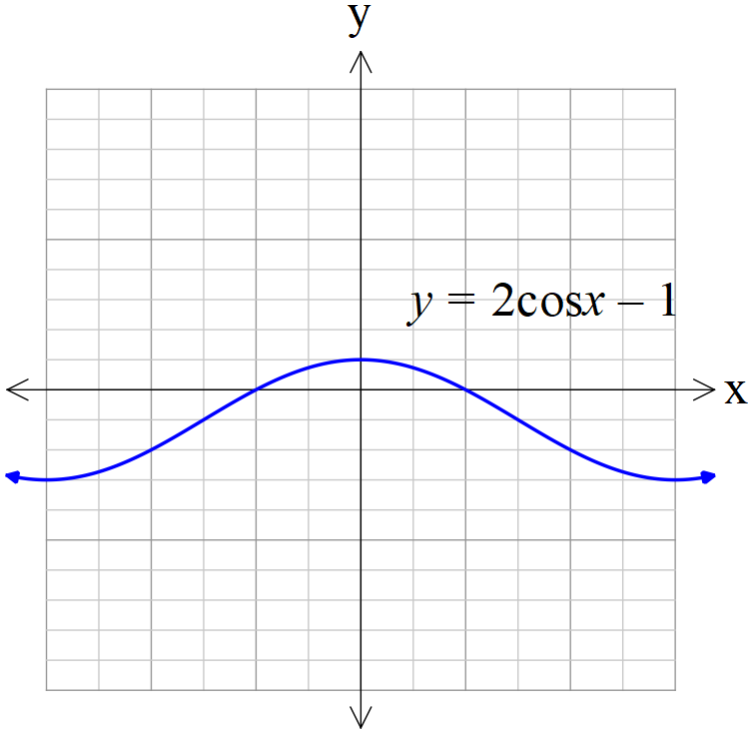

**Question 3 (6 marks)**

Determine whether the following could be a probability density function on the given interval. Explain with reasons. (Assume that  for all values other than what is specified.)

1. $f\left(x\right)=\frac{2}{3} (x^{2}-x)$ $for the interval -1≤x≤2.$ (2 marks)
2.  (2 marks)
3. . (2 marks)

**Question 4 (8 marks)**

1. Given that , determine . (4 marks)
2. Solve for  if $3\log_{3}\left(x\right)+\log_{3}\left(2x-1\right)- 2\log_{3}\left(x\right)=1$ (4 marks)

Question 5 (10 marks)

1. Determine $f(t)$ if $f^{''}\left(t\right)=2e^{t}+3\sin\left(t\right)$ and $f\left(0\right)=0, f^{'}\left(0\right)=0.$ (4 marks)
2. Evaluate  (3 marks)
3. Determine  (3 marks)

Question 6 (7 marks)

Two very slow cars are positioned at time  hours at the positions shown in the diagram below. Car A is moving North at 4 km/h while car B is moving West at 6 km/h.

1. Show that the distance between the two cars at time  hours is given by  km. (2 marks)

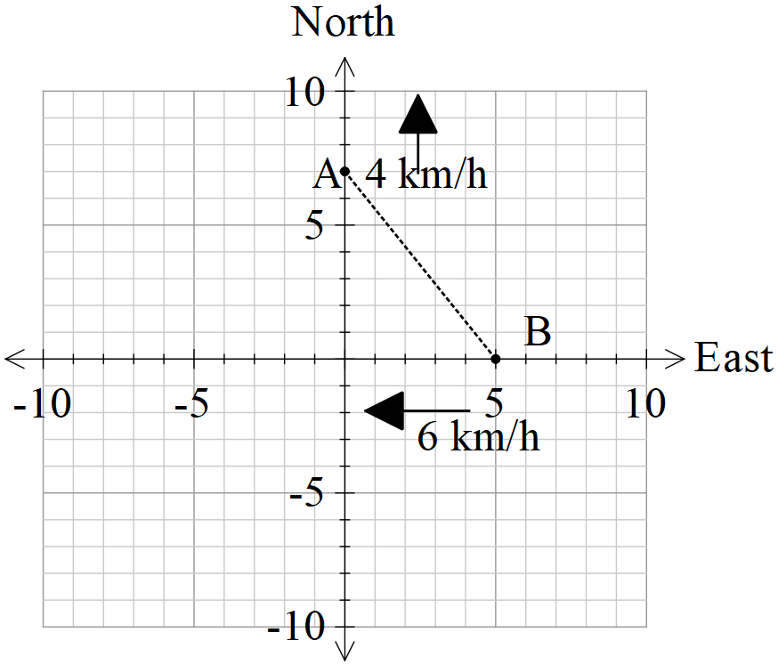

1. Determine using calculus, the time in hours that the separation is a minimum.

Show that this is indeed a minimum. (5 marks)

Question 7 (7 marks)

Sketch the graph of a continuous function $y=f\left(x\right)$ which satisfies all the following conditions:

* Domain of $f\left(x\right)$ is 
* , ,
*  for ,  for 
* 
* 
* 

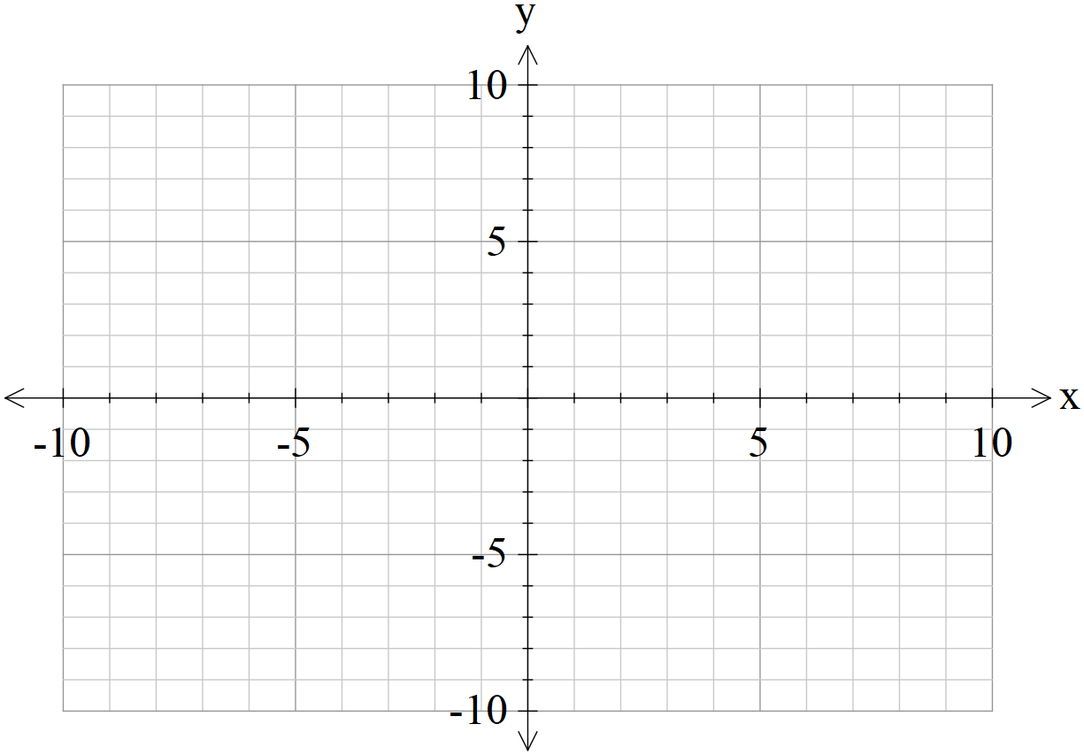

Additional working space

Question number: _________

Additional working space

Question number: _________

Additional working space

Question number: _________